Register No: **1518102066**

Exercise No: **1**

Date:**15.10.2020**

**Aim:**

To print the calendar of a given month and year.

**Program:**

import calendar

year=int(input())

month=int(input())

if(year<10000 and year>999 and month<13 and month>0):

print(calendar.month(year,month))

else:

print("Invalid Input")

**Link:**

<http://103.53.53.18/mod/vpl/forms/submissionview.php?id=229&userid=1681>

**Output:**

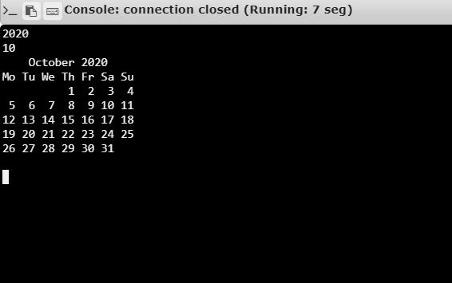

**Result:**

Thus, the code has been successfully executed and output is verified.